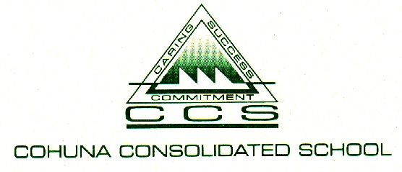

Child Safety Induction Pack – Volunteers/Contractors

Purpose
Thank you for your interest in volunteering/working at our school. The purpose of this induction pack is to ensure Cohuna Consolidated (CCS) volunteers and contractors are familiar with our policies and procedures relating to child safety and understand the important role they play in maintaining and promoting the safety of our students.
Volunteers and contractors must read the suite of policies and procedures in the links below before commencing any work where children are likely to be present.

Key messages
- CCS is committed to the safety and wellbeing of all children. We want children attending our school to be safe, happy and respected.
- We are committed to creating inclusive environment where diversity is supported and students feel safe to bring their whole selves to school.
- Allegations and concerns relating to the safety and wellbeing of our school community will be treated very seriously and consistently with our policies and procedures.
- We are committed to preventing child abuse, identifying risks early and removing and reducing these risks.
- Everyone has a role to ensure children are safe – if something doesn’t feel right, speak up. If you have any concerns about any inappropriate behaviours in the school community you should speak to the Principal. If this would not be appropriate in the circumstances, you can contact the Regional Office of the Department of Education and Training on 1300 338 691.

Induction materials – must read
This induction pack contains the following documents that all new volunteers must read and familiarise themselves with. Please click on the hyperlinks to access each document. If you would prefer a hard copy of this pack, please contact the team in the office who will happily provide you with one.
- CCS Volunteers Policy
- CCS Child Safety and Wellbeing Policy
- CCS Child Safety Responding and Reporting Obligations Policy and Procedures
- CCS Child Safety Code of Conduct
- PROTECT: Four Critical Actions for Schools – Responding to incidents, disclosures and suspicions of child abuse
- PROTECT: Identify child abuse

Contact
We value your feedback on ways we can continue to improve and strengthen our child safety approach and encourage you to contact Valerie Lobry with any comments or questions.

